Movement Ideas for fundraising and awareness

Running
- ​Dedicate one day a week of your running. Use an app to keep up with your distance or time.
- Run a "5K a day" during the month
- Virtual Race - Do a 5K, 10K, half marathon, or a full marathon on your own and have your friends support you.
- Sign up for a Local 5k
- Track your time or distance on your treadmill
Working Out/Lifting
- ​Encourage your CrossFit group to join.
- Sponsor a weight lifting competition.
- Dedicate your time during personal training or boot camps.
Dancing
- ​Put together a group for a day of Zumba.
- Dedicate a class or multiple classes of Barre Fitness. Consider asking your instructor or other class members to join you.
- Organize a dance-a-thon

Walking
- Dedicate a daily 20-minute walk around your neighborhood.
- Walk on your treadmill for a specific distance daily or weekly.
- Invite a friend to walk a specific route during the month.
- Challenge yourself to walk the longest distance you've ever walked.
Yoga
- Dedicate your daily session and ask your friends and family to sponsor that time.
- Ask your Yogi to dedicate a class or even multiple classes to raise funds.
- Grab a friend and commit to a weekly session together.
Cycling
- Kids can choose to ride to school every day for a week or for the month. ​
- Cycle around a local park.
- Join a riding group that rides weekly
- Dedicate one day during the month to ride a specific route.
- Families can ride in their neighborhoods.

 | Name of Sponsors |  | Address | Pledge  (per___) | Maximum  Pledge | Amount  Collected from  Sponsor | Business  Matching  Pledge Amount
1
2
3
4
5
6
7 |  |  |  | 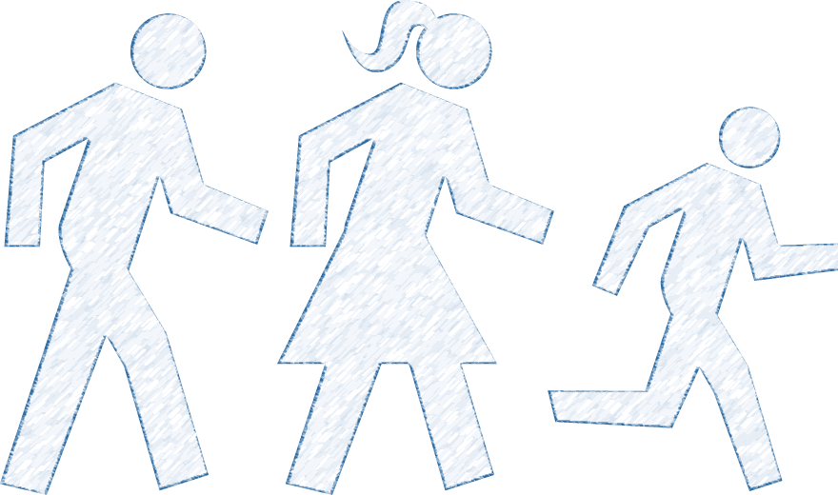
8
9
10
11
12
13
14
15
16
17
18

Dear Potential Sponsor,
I am participating in the My Refuge House Movement for Freedom campaign. My Refuge House is a 501(c)(3) non-profit that provides a safe home to empower and restore survivors of commercial sexual exploitation (CSE) and abuse. All proceeds will help fund their holistic care intended to enable survivors educationally, spiritually, physically, emotionally, and mentally to stand on their own again.
The Movement for Freedom campaign is an opportunity for me to exercise/move to help raise funds and awareness regarding human trafficking. You can sponsor me for an amount per time the exercise is done and can name a maximum amount that you are willing to contribute. You may also consider asking your employer if they might do a matching donation for their employees. After Movement for Freedom concludes I will contact you to collect your contribution. You may choose to donate today as well. Make checks payable to My Refuge House. All contributions are tax-deductible. Thank you!

Movement for Freedom is a fun opportunity to move your body and help change a life. You can run, walk, dance, yoga, bike, or even jump. These are all things that can be used to participate in Movement for Freedom.
Our goal is to help raise funds for My Refuge House. MRH provides holistic care intended to help human trafficking survivors stand on their own again. We believe that Movement for Freedom is something everyone can do. Individuals or groups commit to donating funds connected to movement. The more you move, the more you raise, more lives will be changed. Thank you very much for your participation!
Rules
- Choose the way you want to move and register at movementforfreedom.com . Be sure to check out our list of movement ideas or go to Movementforfreedom.com for ideas there.

- Find Sponsors. You may start collecting pledges as soon as you choose to. We ask that you turn in any/all donations by the end of May with all donations received by June 9th. Those contributions can be made at http://www.myrefugehouse.org/give/ or you can mail them to 255 E. Santa Clara Street Suite #100 Arcadia, CA 91006

Pledges may be made by anyone. Please ask everyone who pledges if their company has a matching gift fund policy. Listed below are a few companies known to do matching gifts.

General Electric
Soros Fund Management
BP (British Petroleum)
Gap Corporation
State Street Corporation ExxonMobil
CarMax
Johnson & Johnson
Choice Hotels
Microsoft
Pfizer
Capital Group
Bristol-Myers Squibb
Coca-Cola
IBM
Avon
Air Products and Chemicals American Express
FM Global
MBIA

- Get moving! Movement for Freedom begins the first day of May.

We look forward to all our participants having a great time! For questions or concerns, email kim@myrefugehouse.org .

